ATOC7500 – Application Lab #2
Regression, Autocorrelation, Red Noise Timeseries
in class Feb. 10/15, 2022

Notebook #1 – Autocorrelation and Effective Sample Size using Fort Collins, Colorado weather observations
ATOC5860_applicationlab2_AR1_Nstar.ipynb

LEARNING GOALS:
1) Calculate the autocorrelation at a range of lags using two methods available in python (np.correlate, dot products)
2) Estimate the effective sample size (N*) using the lag-1 autocorrelation
3) Evaluate the influence of changing the sampling frequency and the specified weather variable on the memory/redness of the data as quantified by the autocorrelation and N*.

DATA and UNDERLYING SCIENCE:
In this notebook, you will analyze the memory (red noise) in weather observations from Fort Collins, Colorado at Christman Field. The observations are from one year, but are sampled hourly. The default settings for the notebook analyze the air temperature in degrees F sampled once daily (every midnight). But other standard weather variables and sampling frequencies can also be easily analyzed. The file containing the data is called christman_2016.csv and it is a comma-delimited text file.

Non-exhaustive Questions to guide your analysis of Notebook #1:

1) Start with the default settings in the code. In other words – Read in the data and find the air temperature every 24 hours (every midnight) over the entire year. Calculate the lag-1 autocorrelation using np.correlate and the direct method using dot products. Compare the python syntax for calculating the autocorrelation with the formulas in Barnes. Equation numbers are provided to refer you back to the Barnes Notes. What is the lag-1 autocorrelation?
The lag-1 autocorrelation using both np.correlate and np.dot is 0.846. Although calculating the autocorrelation with the equations in Barnes is longer, it computationally takes less time.
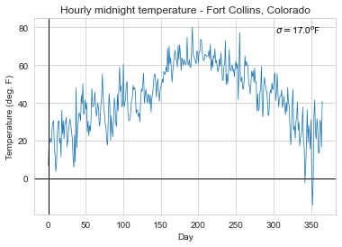
2) Calculate the autocorrelation at a range of lags using np.correlate and the direct method using dot products. Compare the python syntax for calculating the autocorrelation with the formulas in Barnes. Equation numbers are provided to refer you back to the Barnes Notes. How does the autocorrelation change as you vary the lag from -40 days to +40 days?
Once again, np.correlate and direct method using dot products achieves the same goal. The first method is more succinct, but the second is a way to see what the function is doing. Varying the lag from –40 to +40 days, the dataset has an autocorrelation greater than 0.50 between –30 to +30 days. The autocorrelation peaks at a lag of 0 days (as it should) and decreases to an autocorrelation of 0.75.
Weather observations

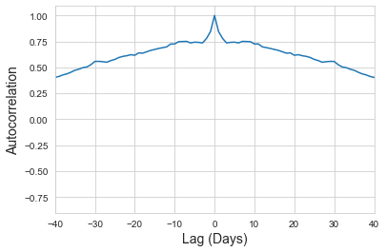

3) Calculate the effective sample size (N*) and compare it to your original sample size (N). Equation numbers are provided to refer you back to the Barnes Notes. How much memory is there in temperature sampled every midnight?
The original sample size is 366. The calculated effective sample size is 31, which is considerably smaller and suggests that there is a lot of memory in temperature sampled every midnight.

4) Now you are ready to tinker … i.e., make minor adjustments to the code with the parameters set in the code to see how your results change. Suggestion: Make a copy of the notebook for your tinkering so that you can refer back to your original answers and the unmodified original code. For example: Repeat steps 1-3) above with a different variable (e.g., relative humidity (RH), wind speed (wind_mph)). Repeat steps 1-3) above with a different temporal sampling frequency (e.g., every 12 hours, every 6 hours, every 4 days). How do you answers change?
Changing the variable to wind speed in miles per hour, the autocorrelation decreases to –0.04 and the effective sample size increases to 335, which is close to the original sample size of 366. This suggests that there is much less memory in wind speed than in temperature.

Changing the variable back to temperature but changing the temporal sampling frequency to every six hours, the autocorrelation is high at 0.76 and the effective sample size is 198. This suggests that there is a descent amount of memory.

Notebook #2 – Red noise time series generation, Regression, and Statistical Significance Testing While Regressing
ATOC5860_applicationlab2_AR1_regression_AO.ipynb

LEARNING GOALS:
1) Calculate and analyze the autocorrelation at a range of lags using output from an EOF analysis (the Arctic Oscillation Index).
2) Generate a red noise time series with equivalent memory as an observed time series (i.e., given lag-1 autocorrelation).
3) Correlate two time series and calculate the statistical significance.
4) Evaluate the statistical significance obtained in the context of the number of chances provided for success. What happens when you go “fishing” for correlations and give yourself lots of opportunity for success? Can you critically evaluate the chances that your regression is statistically different than 0 just by chance?

DATA and UNDERLYING SCIENCE:
In this notebook, you will analyze the monthly Arctic Oscillation (AO) timeseries from January 1950 to present. The AO timeseries comes from an Empirical Orthogonal Function (EOF) analysis. We will implement EOFs in the next application lab so in this lab we are actually using multiple analysis methods introduced in this class, some that you have learned and some that you are still yet to learn .

How do you find the AO value each month? To identify the atmospheric circulation patterns that explain the most variance, NOAA regularly applies EOF analysis to the monthly mean 1000-hPa height anomalies poleward of 20° latitude for the Northern Hemisphere. The AO spatial pattern (Figure 1 below) emerges as the first EOF (explaining the most variance, 19%). The AO timeseries we will analyze is a measure of the amplitude of the pattern in Figure 1 in a given month. In other words – the AO timeseries is the first principal component (a timeseries) associated with the first EOF (a spatial structure). More information on the EOF analysis here:
http://www.cpc.ncep.noaa.gov/products/precip/CWlink/daily_ao_index/history/method.shtml

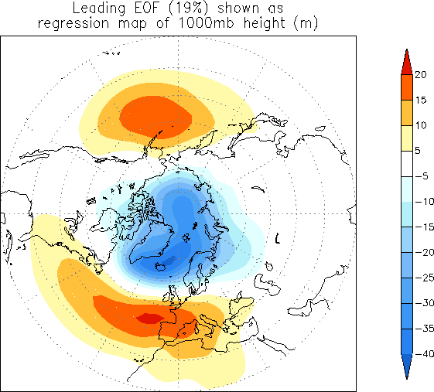
Figure 1. The loading pattern of the Arctic Oscillation (AO), i.e., the structure explaining the most variance of monthly mean 1000mb height during 1979-2000 period. In other words – this is the first EOF.

The data are available and regularly updated here:
http://www.cpc.ncep.noaa.gov/products/precip/CWlink/pna/norm.nao.monthly.b5001.current.ascii

You can work with the data directly on the web (assuming you have an internet connection). I have also downloaded the data and made them available – The name of the data file is “monthly.ao.index.b50.current.ascii”.

Questions to guide your analysis of Notebook #2:

1) Start with the default settings in the code. First read in the Arctic Oscillation (AO) data. Look at your data!! Plot it as a timeseries. Save the timeseries plot as a postscript file and put it in this document.
Monthly AO Timeseries
Year

2) Calculate the lag-one autocorrelation (AR1) of the AO data and record it here. Use two methods (np.correlate, dot products). Check that they give you the same result. Interpret the value. How much memory (red noise) is there in the AO from month to month?
Using both methods, the autocorrelation is 0.30855. This is a small autocorrelation, suggesting there is little memory, or red noise, in the AO from month to month.

3) Calculate and plot the autocorrelation of the AO data at all lags. Describe your results. How red are the data at lags other than lag=1? Is there any interesting behavior of the autocorrelation as a function of lag? What would you expect for red noise timeseries with an AR1=value reported in 2)?
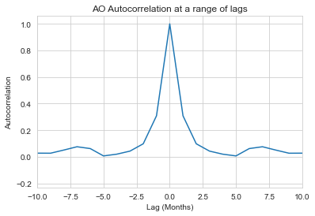
The AO data has an autocorrelation between 0.0 and 0.2 outside of a one-month lag (lag=1). This suggests that the data at other lags is not very red and has low memory. It’s interesting that the autocorrelation decreases to 0 at a 5 month lag but increases to around 0.1 again at a 7th month lag. It’s also interesting that the AR1 value of ~0.31, the lag is only greater than 0.3 within a one-month lag. I would have expected a lag to hover around 0.3 for more months.

4) Generate a synthetic red noise time series with the same lag-1 autocorrelation as the AO data. Your synthetic dataset should have different time evolution but the same memory as the AO. Plot the AO timeseries and the synthetic red noise time series. Put the plot below.
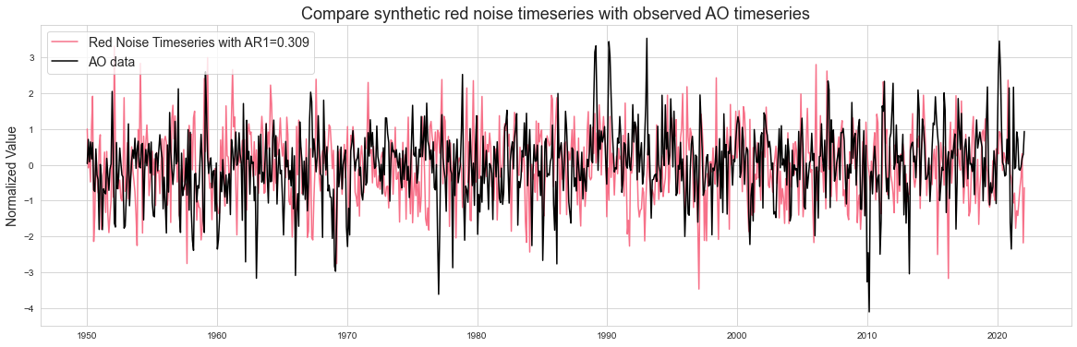

5) Do you expect to find any correlation between the two datasets, i.e., the synthetic red noise and the actual AO data? What is the correlation between the synthetic red noise and the actual AO data? Calculate a regression coefficient and other associated regression statistics.
I would expect to find correlation between the two datasets if I cherry-picked the lag to match the lag the red noise was created with. However, if this value is not chosen, I expect a low correlation between the synthetic red noise and the actual AO data. The percent of variance explained, is 0.5%.

6) Next -- Have some fun and go “fishing for correlations”. What happens if you try correlating subsets of the two datasets many times? When you try 200 times -- what is the maximum correlation/variance explained you can obtain between the synthetic red noise and the actual data? Note: you are effectively searching for a high correlation with no a priori reason to do so.... THIS IS NOT good practice for science but we are doing it here because it is instructive to see what happens :)
The maximum variance explained after trying 200 times is 29.78% (as compared to the 0.5% from before).

7) Calculate the correlation statistics for the highest correlation obtained in question 6). Two methods are provided - they should give you the same answers. Place a confidence interval on your correlation. Because you have found a correlation that is not equal to 0, use the Fisher-Z Transformation. Did your "fishing" for a statistically significant correlation work? Is your highest correlation statistically significant (i.e., can you reject the null hypothesis that the correlation is zero)? Write out the steps for hypothesis testing and use the values you calculate to formally assess.
Using the highest correlation from question 6, the r-value confidence interval is 0.1 to 0.81. Although the variance explained increased, “fishing” for a statistically significant correlation did not work, so we cannot reject the null hypothesis that the correlation is zero. Using the five-steps of hypothesis testing, this is:
Step 1: State the significance level ($α$).
At the 95% confidence level for the standardized sample, $α=1-0.95=0.05$.
Step 2: State the null hypothesis $H_{0}$ and the alternative $H_{1}$.
$$H_{0}=the correlation is zero$$
$$H_{1}=the correlation is not zero$$
Step 3: State the statistic to be used, and the assumptions required to use it.
We will use a Fisher-Z transformation to test the correlation coefficient between the red noise data and the AO data. The Fisher-Z statistic will be used because the true correlation is not zero and the underlying distribution is therefore assumed to be not symmetric. The Fisher-Z Transformation normally “transforms” the distribution.
Step 4: State the critical region.
If the confidence range for the true correlation given by $ρ_{min}$ and $ρ_{max}$ does not overlap with 0, we can reject the null hypothesis that the correlation between the two timeseries is 0. If we reject the null hypothesis that the correlation is 0, we have found a false positive.
Step 5: Evaluate the statistic and state the conclusion
At a 95% confidence level, the confidence intervals are 0.1 to 0.81. We can therefore reject the null hypothesis that the correlation is 0 and have found a false positive.

8) You went searching for correlations, you searched long and hard (200 times!) You should have been concerned that the largest correlation you found would be a false positive. Do you think you found a false positive? Explain what you found and potentially why you think it is important statistically but not physically. What lessons did you learn by “fishing for correlations”?
I think I found a false positive. After running the notebook many times, the percent of variance explained fluctuated between 0.07% and 0.6%. The largest correlation of 30% seems like an anomaly that we’ve cherry-picked to use to test for correlation. It’s much more likely that this value would show a correlation. This isn’t representative physically but shows the fault in using statistics. Statistics can be manipulated to show results that we want or that don’t make sense, so we must be careful when pushing for results or when interpreting statistical results.

FOR FUN: Check out - https://www.tylervigen.com/spurious-correlations

